Math 4 Name_______________________________
3-4 Multiplying and Dividing Rational Expressions Date________

Learning goal:
I can manipulate rational expressions into useful equivalent forms by simplifying, adding, subtracting, multiplying, and dividing.

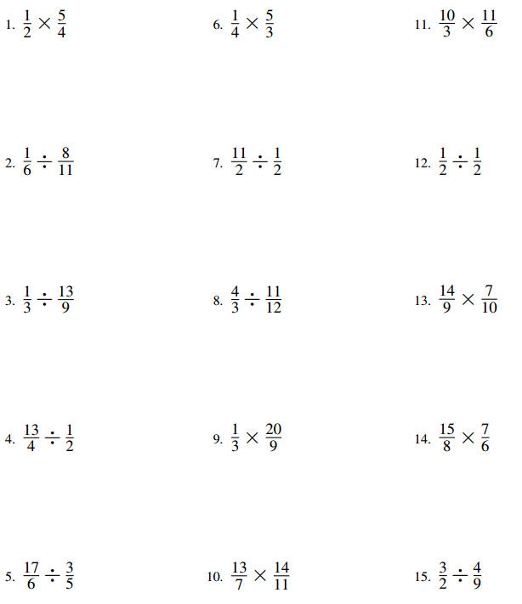
Multiply, divide and simplify the fractions below.
Multiplying Rational Expressions
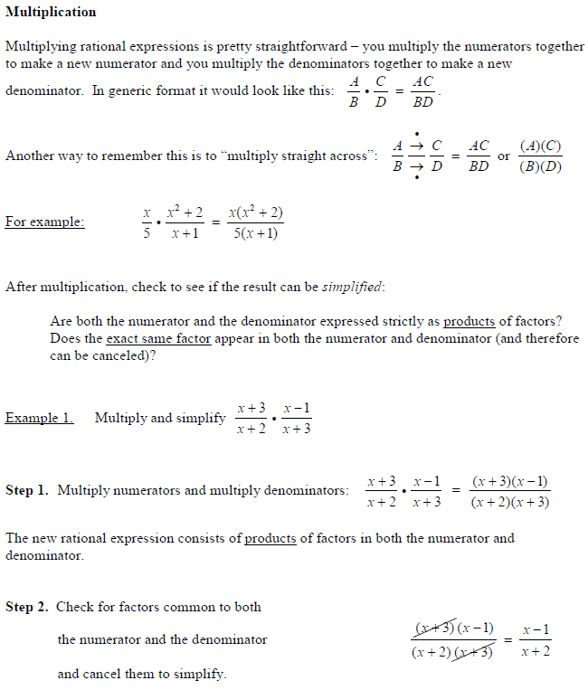

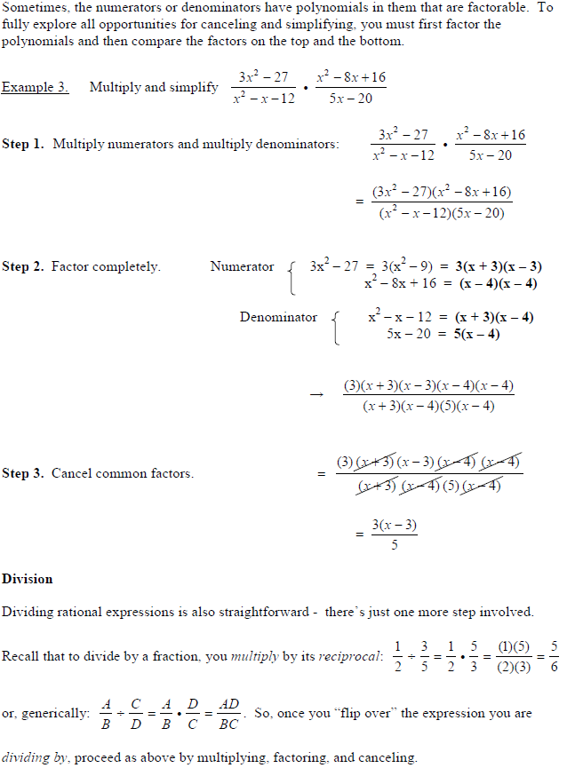

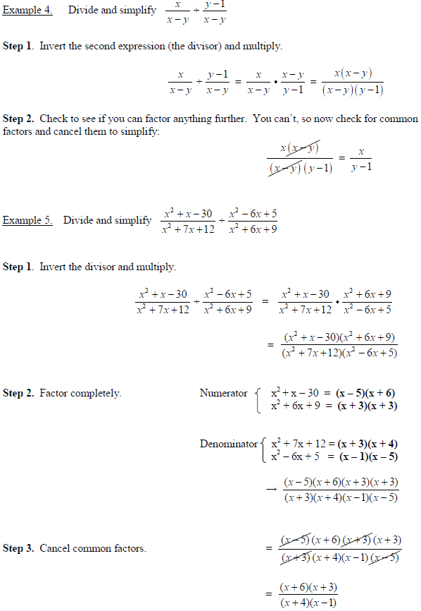

Practice Problems – Show your work on a separate sheet of paper!
